**Hive Assignment-1**

1. **Download vechile sales data ->** <https://github.com/shashank-mishra219/Hive-Class/blob/main/sales_order_data.csv>
2. **Store raw data into hdfs location.**

gopalkrishna@ubuntu:~/KRP$ vi sales_order_data.csv

(Note: Header removed here)

gopalkrishna@ubuntu:~/KRP$ hdfs dfs -mkdir /Hive_assignment1/

gopalkrishna@ubuntu:~/KRP$ hdfs dfs -put /home/gopalkrishna/KRP/sales_order_data.csv /Hive_assignment1

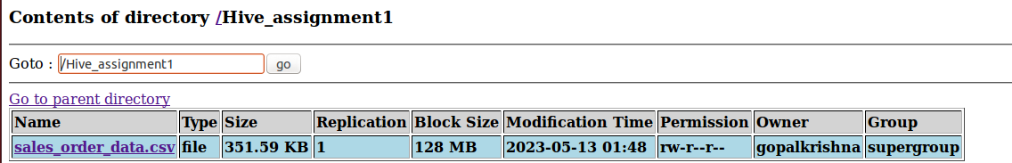

1. **Create a internal hive table "sales_order_csv" which will store csv data sales_order_csv .. make sure to skip header row while creating table**.

hive> create table sales_order_csv(Ordernumber int,Quantity_ordered int,Price_each float,Order_line_number int,Sales float,Status string,Qtr_id int,Month_id int,Year_id int,Productline string,MSRP int,Product_code string,Phone string,City string,State string,Postal_code string,Country string,Territory string,Contact_last_name string,Contact_first_name string,Deal_size string)

> row format delimited

> fields terminated by ','

> lines terminated by '\n'

> stored as textfile;

OK

Time taken: 0.888 seconds

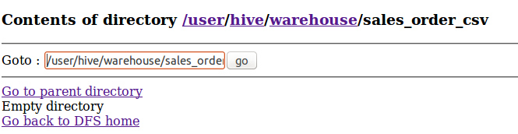

1. **Load data from hdfs path into "sales_order_csv".**

hive> load data inpath '/Hive_assignment1/sales_order_data.csv' into table sales_order_csv;

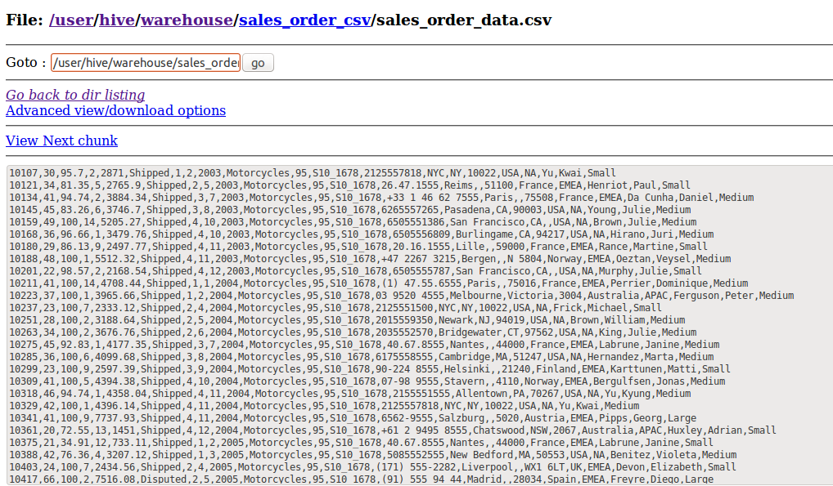

1. **Create an internal hive table which will store data in ORC format "sales_order_orc".**

hive> create table sales_order_orc(Ordernumber int,Quantity_ordered int,Price_each float,Order_line_number int,Sales float,Status string,Qtr_id int,Month_id int,Year_id int,Productline string,MSRP int,Product_code string,Phone string,City string,State string,Postal_code string,Country string,Territory string,Contact_last_name string,Contact_first_name string,Deal_size string)

> row format delimited

> fields terminated by ','

> lines terminated by '\n'

> stored as orc;

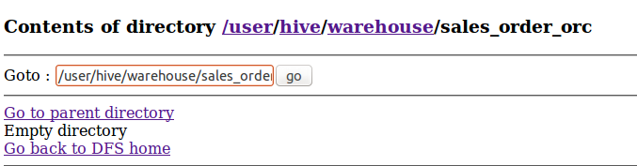

1. **Load data from "sales_order_csv" into "sales_order_orc".**

hive> insert overwrite table sales_order_orc select * from sales_order_csv;

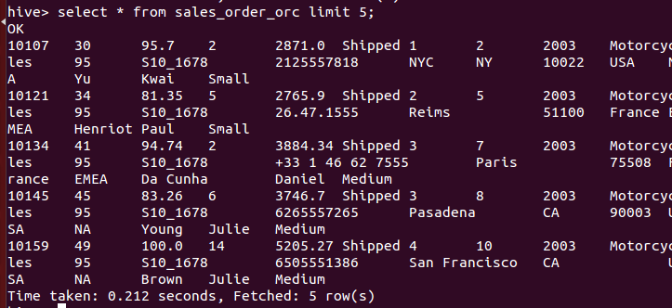

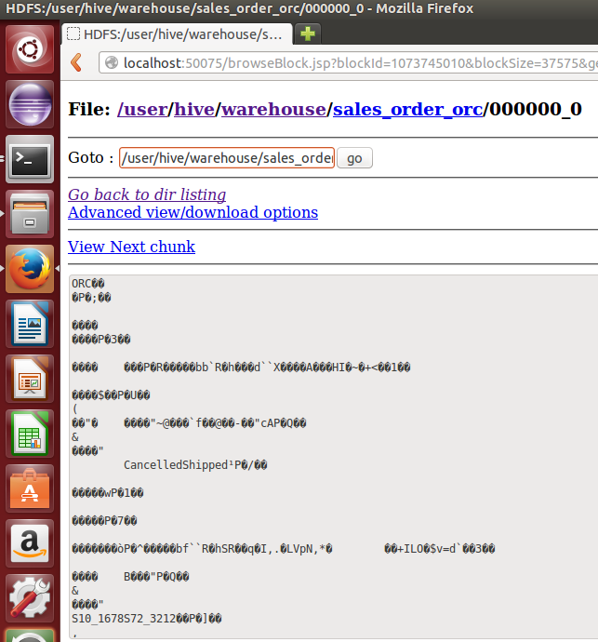

**🡺 Perform below menioned queries on "sales_order_orc" table** :

1. **Calculatye total sales per year:**

hive> select Year_id, Round(sum(Sales), 2) as Total_sales_per_year from sales_order_orc group by Year_id order by Year_id;

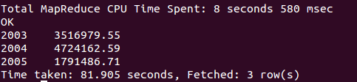

1. **Find a product for which maximum orders were placed.**

hive> select Product_code,count(Ordernumber) as Max_ordered_product from sales_order_orc group by Product_code order by Max_ordered_product desc limit 1;

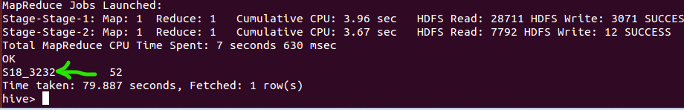

1. **Calculate the total sales for each quarter.**

hive> select Qtr_id,round(sum(Sales),2) as sales_per_qtr from sales_order_orc group by Qtr_id;

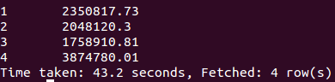

1. **In which quarter sales was minimum.**

hive> select Qtr_id,round(sum(Sales),2) as sales_per_qtr from sales_order_orc group by Qtr_id order by sales_per_qtr limit 1;



1. **In which country sales was maximum and in which country sales was minimum.**

hive> select Country,round(sum(Sales),2) as sales_per_country from sales_order_orc group by Country order by sales_per_country desc limit 1;



hive> select Country,round(sum(Sales),2) as sales_per_country from sales_order_orc group by Country order by sales_per_country limit 1;

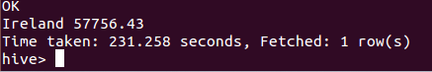

1. **Calculate quartelry sales for each city.**

hive> select City,Qtr_id,round(sum(Sales),2) from sales_order_orc group by City,Qtr_id order by City,Qtr_id;

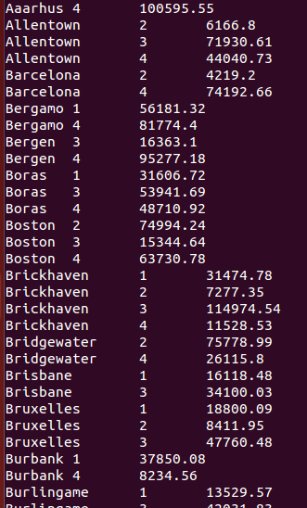

1. **Find a month for each year in which maximum number of quantities were sold.**

hive> with abc as (select year_id, month_id, sum(quantity_ordered) as qty from sales_order_orc group by year_id, month_id),xyz as (select year_id, month_id, qty,row_number() over(partition by year_id order by year_id, qty desc) ranking from abc) select year_id, month_id, qty as Qty_sold from xyz where ranking = 1;

